**VISVESVARAYA TECHNOLOGICAL UNIVERSITY**

**“JnanaSangama”, Belgaum -590014, Karnataka.**



**LAB REPORT**

**on**

**BIG DATA ANALYTICS**

**(20CS6PEBDA)**

***Submitted by***

**KANALA BHUVANA REDDY (1BM19CS069)**

***in partial fulfillment for the award of the degree of***

**BACHELOR OF ENGINEERING**

***in***

**COMPUTER SCIENCE AND ENGINEERING**



**B.M.S. COLLEGE OF ENGINEERING**

**(Autonomous Institution under VTU)**

**BENGALURU-560019**

**May-2022 to July-2022**

**B. M. S. College of Engineering,**

**Bull Temple Road, Bangalore 560019**

(Affiliated To Visvesvaraya Technological University, Belgaum)

**Department of Computer Science and Engineering**



**CERTIFICATE**

This is to certify that the Lab work entitled “**BIG DATA ANALYTICS**” carried out by **KANALA BHUVANA REDDY (1BM19CS069),** who is bonafide student of **B. M. S. College of Engineering.** It is in partial fulfillment for the award of **Bachelor of Engineering in Computer Science and Engineering** of the Visvesvaraya Technological University, Belgaum during the year 2022. The Lab report has been approved as it satisfies the academic requirements in respect of a **Course Title - (Course code)** work prescribed for the said degree.

Name of the Lab-Incharge                **Antara Roy Choudhury**

Designation Assistant Professor

Department of CSE Department of CSE

BMSCE, Bengaluru BMSCE, Bengaluru

`

**Index Sheet**

|  |  |  |
| --- | --- | --- |
| **Sl. No.** | **Experiment Title** | **Page No.** |
| **1** | **MongoDB CRUD Demonstration** | **4** |
| **2** | **Cassandra-Employee Database** | **7** |
| **3** | **Cassandra-Library Database** | **10** |
|  |  |  |
|  |  |  |
|  |  |  |
|  |  |  |
|  |  |  |
|  |  |  |
|  |  |  |
|  |  |  |
|  |  |  |
|  |  |  |
|  |  |  |
|  |  |  |

**Course Outcome**

|  |  |
| --- | --- |
| CO1 | Apply the concept of NoSQL, Hadoop or Spark for a given task |
| CO2 | Analyze the Big Data and obtain insight using data analytics mechanisms. |
| CO3 | Design and implement Big data applications by applying NoSQL, Hadoop or Spark |

### Experiment 1

1

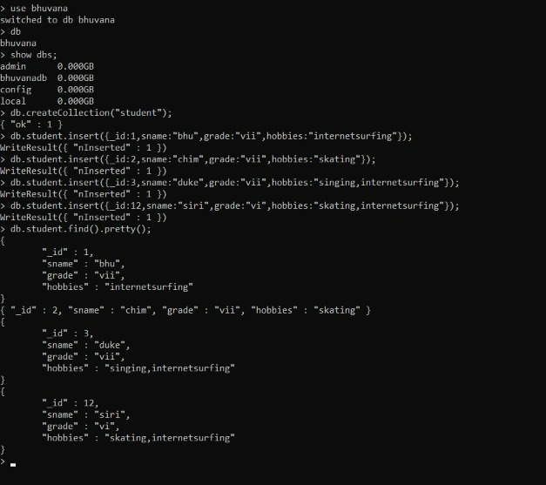

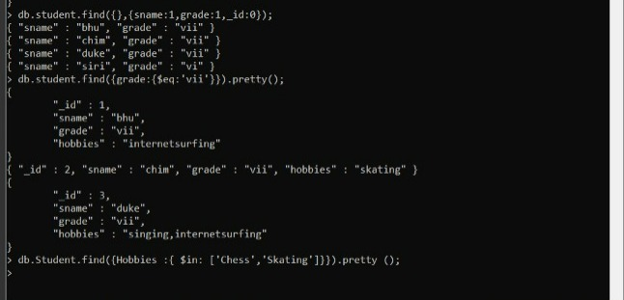

|  |
| --- |
|  |
| > db.Student.find({Grade:{$eq:'vii'}}); |
|  | { "_id" : 1, "StudName" : "Megha", "Grade" : "vii", "Hobbies" : "InternetSurfing" } |
|  | { "_id" : 3, "Grade" : "vii", "StudName" : "Ayan", "Hobbies" : "skating" } |
|  | > db.Student.find({Grade:{$eq:'vii'}}).pretty(); |
|  | { |
|  | "_id" : 1, |
|  | "StudName" : "Megha", |
|  | "Grade" : "vii", |
|  | "Hobbies" : "InternetSurfing" |
|  | } |
|  | { "_id" : 3, "Grade" : "vii", "StudName" : "Ayan", "Hobbies" : "skating" } |
|  | > db.Student.find({Hobbies:{$in:['Chess','Skating']}}).pretty(); |
|  | > db.Student.find({Hobbies:{$in:['Skating']}}).pretty(); |
|  | > db.Student.find({Hobbies:{$in:['skating']}}).pretty(); |
|  | { "_id" : 3, "Grade" : "vii", "StudName" : "Ayan", "Hobbies" : "skating" } |
|  | > db.Student.find({StudName:/^M/}).pretty(); |
|  | { |
|  | "_id" : 1, |
|  | "StudName" : "Megha", |
|  | "Grade" : "vii", |
|  | "Hobbies" : "InternetSurfing" |
|  | } |
|  | > db.Student.find({StudName:/e/}).pretty(); |
|  | { |
|  | "_id" : 1, |
|  | "StudName" : "Megha", |
|  | "Grade" : "vii", |
|  | "Hobbies" : "InternetSurfing" |
|  | } |
|  | > db.Student.count(); |
|  | 2 |
|  | > db.Student.find().sort({StudName:-1}).pretty(); |
|  | { |
|  | "_id" : 1, |
|  | "StudName" : "Megha", |
|  | "Grade" : "vii", |
|  | "Hobbies" : "InternetSurfing" |
|  | } |
|  | { "_id" : 3, "Grade" : "vii", "StudName" : "Ayan", "Hobbies" : "skating" } |
|  | > db.Student.save({StudName:"Vamsi",Greade:"vi"}) |
|  | WriteResult({ "nInserted" : 1 }) |
|  | > db.Students.update({_id:4},{$set:{Location:"Network"}}) |
|  | WriteResult({ "nMatched" : 0, "nUpserted" : 0, "nModified" : 0 }) |
|  | > db.Students.update({_id:4},{$unset:{Location:"Network"}}) |
|  | WriteResult({ "nMatched" : 0, "nUpserted" : 0, "nModified" : 0 }) |
|  | > db.Student.find({_id:1},{StudName:1,Grade:1,_id:0}); |
|  | { "StudName" : "Megha", "Grade" : "vii" } |
|  | > db.Student.find({Grade:{$ne:'VII'}}).pretty(); |
|  | { |
|  | "_id" : 1, |
|  | "StudName" : "Megha", |
|  | "Grade" : "vii", |
|  | "Hobbies" : "InternetSurfing" |
|  | } |
|  | { "_id" : 3, "Grade" : "vii", "StudName" : "Ayan", "Hobbies" : "skating" } |
|  | { |
|  | "_id" : ObjectId("6253f413e88b8c9e787b194e"), |
|  | "StudName" : "Vamsi", |
|  | "Greade" : "vi" |
|  | } |
|  | > db.Student.find({StudName:/s$/}).pretty(); |
|  | > db.Students.update({_id:3},{$set:{Location:null}}) |
|  | WriteResult({ "nMatched" : 0, "nUpserted" : 0, "nModified" : 0 }) |
|  | > db.Students.count() |
|  | 0 |
|  | > db.Students.count({Grade:"VII"}) |
|  | 0 |
|  | > db.Student.find({Grade:"VII"}).limit(3).pretty(); |
|  | > db.Student.update({_id:3},{$set:{Location:null}}) |
|  | WriteResult({ "nMatched" : 1, "nUpserted" : 0, "nModified" : 1 }) |
|  | > db.Student.count({Grade:"VII"}) |
|  | 0 |
|  | > db.Students.count({Grade:"vii"}) |
|  | 0 |
|  | > db.Student.count() |
|  | 3 |
|  | > db.Student.count({Grade:"vii"}) |
|  | 2 |
|  | > db.Student.find({Grade:"vii"}).limit(3).pretty(); |
|  | { |
|  | "_id" : 1, |
|  | "StudName" : "Megha", |
|  | "Grade" : "vii", |
|  | "Hobbies" : "InternetSurfing" |
|  | } |
|  | { |
|  | "_id" : 3, |
|  | "Grade" : "vii", |
|  | "StudName" : "Ayan", |
|  | "Hobbies" : "skating", |
|  | "Location" : null |
|  | } |
|  | > db.Student.find().sort({StudName:1}).pretty(); |
|  | { |
|  | "_id" : 3, |
|  | "Grade" : "vii", |
|  | "StudName" : "Ayan", |
|  | "Hobbies" : "skating", |
|  | "Location" : null |
|  | } |
|  | { |
|  | "_id" : 1, |
|  | "StudName" : "Megha", |
|  | "Grade" : "vii", |
|  | "Hobbies" : "InternetSurfing" |
|  | } |
|  | { |
|  | "_id" : ObjectId("6253f413e88b8c9e787b194e"), |
|  | "StudName" : "Vamsi", |
|  | "Greade" : "vi" |
|  | } |
|  | > db.Student.find().skip(2).pretty() |
|  | { |
|  | "_id" : ObjectId("6253f413e88b8c9e787b194e"), |
|  | "StudName" : "Vamsi", |
|  | "Greade" : "vi" |
|  | } |
|  | > db.food.insert( { _id:1, fruits:['grapes','mango','apple';] } ) |
|  | 2022-04-11T15:05:51.894+0530 E QUERY [thread1] SyntaxError: missing ] after element list @(shell):1:57 |
|  | > db.food.insert({_id:1,fruits:['grapes','mango','apple']}) |
|  | WriteResult({ "nInserted" : 1 }) |
|  | > db.food.insert({_id:2,fruits:['grapes','mango','cherry']}) |
|  | WriteResult({ "nInserted" : 1 }) |
|  | > db.food.insert({_id:3,fruits:['banana','mango']}) |
|  | WriteResult({ "nInserted" : 1 }) |
|  | > db.food.find({fruits:['grapes','mango','apple']}).pretty(); |
|  | { "_id" : 1, "fruits" : [ "grapes", "mango", "apple" ] } |
|  | > db.food.find({'fruits.1':'grapes'}) |
|  | > db.food.find({"fruits":{$size:2}}) |
|  | { "_id" : 3, "fruits" : [ "banana", "mango" ] } |
|  | > db.food.find({_id:1},{"fruits":{$slice:2}}) |
|  | { "_id" : 1, "fruits" : [ "grapes", "mango" ] } |
|  | > db.food.find({fruits:{$all:["mango","grapes"]}}) |
|  | { "_id" : 1, "fruits" : [ "grapes", "mango", "apple" ] } |
|  | { "_id" : 2, "fruits" : [ "grapes", "mango", "cherry" ] } |
|  | > db.food.update({_id:3},{$set:{"fruits.1":"apple"}}) |
|  | WriteResult({ "nMatched" : 1, "nUpserted" : 0, "nModified" : 1 }) |
|  | > db.food.update({_id:2},{$push:{price:{grapes:80,mango:200,cherry:100}}}) |
|  | WriteResult({ "nMatched" : 1, "nUpserted" : 0, "nModified" : 1 }) |
|  | > |
|  | > |
|  | > |
|  | > |
|  | > |
|  | > db.createCollection("Customers"); |
|  | { |
|  | "ok" : 0, |
|  | "errmsg" : "a collection 'bhuvana.Customers' already exists", |
|  | "code" : 48, |
|  | "codeName" : "NamespaceExists" |
|  | } |
|  | db.Customers.insert({_custID:1,AcctBal:'100000',AcctType:"saving"}); |
|  | WriteResult({ "nInserted" : 1 }) |
|  | > db.Customers.aggregate({$group:{_id:"$custID",TotAccBal:{$sum:"$AccBal"}}}); |
|  | { "_id" : null, "TotAccBal" : 0 } |
|  | db.Customers.aggregate({$match:{AcctType:"saving"}},{$group:{_id:"$custID",TotAccBal:{$sum:"$AccBal"}}}); |
|  | { "_id" : null, "TotAccBal" : 0 } |
|  | db.Customers.aggregate({$match:{AcctType:"saving"}},{$group:{_id:"$custID",TotAccBal:{$sum:"$AccBal"}}},{$match:{TotAccBal:{$gt:1200}}}); |
|  | > |
|  |  |

## EXPERIMENT 2

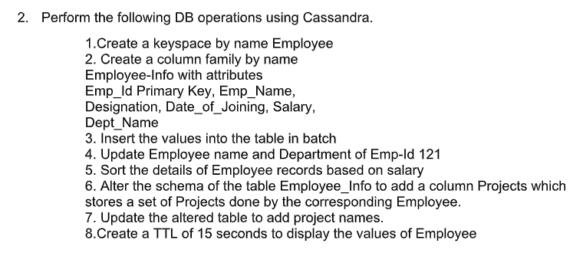

|  |
| --- |
| 1.Create a key space by name Employee |
|  | >CREATE KEYSPACE employee_db WITH replication ={'class':'SimpleStrategy', 'replication_factor' : 3}; |
|  | >use keyspace employee_db; |
|  |  |
|  | 2.Create a column family by name Employee-Info with attributes Emp_Id Primary Key, Emp_Name, Designation, Date_of_Joining, Salary, Dept_Name |
|  | >CREATE TABLE employee_info( |
|  | emp_id int primary key,emp_name text,designation text,date_of_joining timestamp,salary int,dept_name text); |
|  |  |
|  | 3.Insert the values into the table in batch |
|  | >cqlsh:employee_db> begin batch |
|  | insert into employee_info(emp_id,emp_name,designation,date_of_joining,salary,dept_name) |
|  | values(1,'aaa','manager','2021-02-02',500000,'sales') |
|  | insert into employee_info(emp_id,emp_name,designation,date_of_joining,salary,dept_name) |
|  | values(2,'bbb','accountant','2020-02-02',100000,'sales') |
|  | insert into employee_info(emp_id,emp_name,designation,date_of_joining,salary,dept_name) |
|  | values(121,'ccc','accountant','2019-02-02',300000,'marketing') apply batch; |
|  |  |
|  | >cqlsh:employee_db> select * from employee_info; |
|  | emp_id | date_of_joining | dept_name | designation | emp_name | salary |
|  | --------+---------------------------------+-----------+-------------+----------+-------- |
|  | 1 | 2021-02-01 18:30:00.000000+0000 | sales | manager | aaa | 500000 |
|  | 2 | 2020-02-01 18:30:00.000000+0000 | sales | accountant | bbb | 100000 |
|  | 121 | 2019-02-01 18:30:00.000000+0000 | marketing | accountant | ccc | 300000 |
|  |  |
|  |  |
|  |  |
|  | 4.Update Employee name and Department of Emp-Id 121 |
|  | cqlsh:employee_db> update employee_info set emp_name='xyz' where emp_id=121; |
|  | cqlsh:employee_db> update employee_info set dept_name='executive' where emp_id=121; |
|  | cqlsh:employee_db> select * from employee_info; |
|  |  |
|  | emp_id | date_of_joining | dept_name | designation | emp_name | salary |
|  | --------+---------------------------------+-----------+-------------+----------+-------- |
|  | 1 | 2021-02-01 18:30:00.000000+0000 | sales | manager | aaa | 500000 |
|  | 2 | 2020-02-01 18:30:00.000000+0000 | sales | accountant | bbb | 100000 |
|  | 121 | 2019-02-01 18:30:00.000000+0000 | executive | accountant | xyz | 300000 |
|  |  |
|  |  |
|  | 5. Sort the details of Employee records based on salary |
|  |  |
|  | create table emp(id int, salary int,name text, primary key(id,salary)); |
|  |  |
|  | begin batch insert into emp(id,salary,name) values (1,89900,'kjl'); insert into emp(id,salary,name) values (2,70000,'uiu'); apply batch; |
|  |  |
|  | paging off; |
|  | Disabled Query paging. |
|  | cqlsh:employee> select * from emp where id in (1,2) order by salary; |
|  |  |
|  | id | salary | name |
|  | ----+--------+------ |
|  | 2 | 70000 | uiu |
|  | 1 | 89900 | kjl |
|  |  |
|  |  |
|  | 6.Alter the schema of the table Employee_Info to add a column Projects which stores a set of Projects done by the corresponding Employee. |
|  | cqlsh:employee_db> alter table employee_info add projects set<text>; |
|  | cqlsh:employee_db> select * from employee_info; |
|  |  |
|  | emp_id | date_of_joining | dept_name | designation | emp_name | projects | salary |
|  | --------+---------------------------------+-----------+-------------+----------+----------+-------- |
|  | 1 | 2021-02-01 18:30:00.000000+0000 | sales | manager | aaa | null | 500000 |
|  | 2 | 2020-02-01 18:30:00.000000+0000 | sales | accountant | bbb | null | 100000 |
|  | 121 | 2019-02-01 18:30:00.000000+0000 | executive | accountant | xyz | null | 300000 |
|  |  |
|  | (3 rows) |
|  |  |
|  | 7.Update the altered table to add project names. |
|  | cqlsh:employee_db> update employee_info set projects=projects+{'1111'} where emp_id=1; |
|  | cqlsh:employee_db> update employee_info set projects=projects+{'2222'} where emp_id=2; |
|  | cqlsh:employee_db> update employee_info set projects=projects+{'2222'} where emp_id=121; |
|  | cqlsh:employee_db> select * from employee_info; |
|  |  |
|  | emp_id | date_of_joining | dept_name | designation | emp_name | projects | salary |
|  | --------+---------------------------------+-----------+-------------+----------+----------+-------- |
|  | 1 | 2021-02-01 18:30:00.000000+0000 | sales | manager | aaa | {'1111'} | 500000 |
|  | 2 | 2020-02-01 18:30:00.000000+0000 | sales | accountant | bbb | {'2222'} | 100000 |
|  | 121 | 2019-02-01 18:30:00.000000+0000 | executive | accountant | xyz | {'2222'} | 300000 |
|  |  |
|  |  |
|  |  |
|  | 8 Create a TTL of 15 seconds to display the values of Employees. |
|  |  |
|  | insert into employee_info(emp_id,emp_name,designation,date_of_joining,salary,dept_name) |
|  | ... values(4,'abc','manager','2021-02-02',400000,'sales') using ttl 30; |
|  | cqlsh:employee_db> select * from employee_info; |
|  |  |
|  | emp_id | date_of_joining | dept_name | designation | emp_name | projects | salary |
|  | --------+---------------------------------+-----------+-------------+----------+----------+-------- |
|  | 1 | 2021-02-01 18:30:00.000000+0000 | sales | manager | aaa | {'1111'} | 500000 |
|  | 2 | 2020-02-01 18:30:00.000000+0000 | sales | accountant | bbb | {'2222'} | 100000 |
|  | 4 | 2021-02-01 18:30:00.000000+0000 | sales | manager | abc | null | 400000 |
|  | 121 | 2019-02-01 18:30:00.000000+0000 | executive | accountant | xyz | {'2222'} | 300000 |
|  |  |
|  | cqlsh:employee_db> select ttl(emp_name) from employee_info where emp_id=4; |
|  |  |
|  | ttl(emp_name) |
|  | --------------- |
|  |  |
|  | (0 |

**1:**

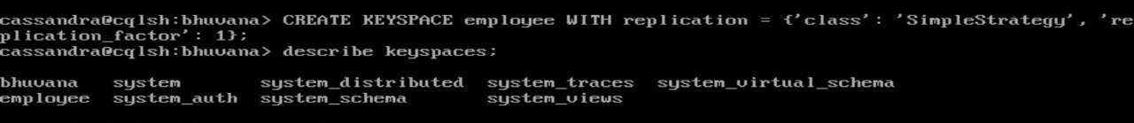

**2,3:**

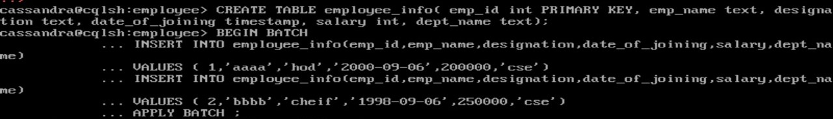

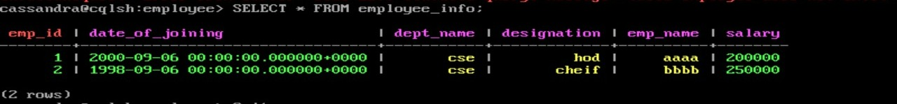

**4:**

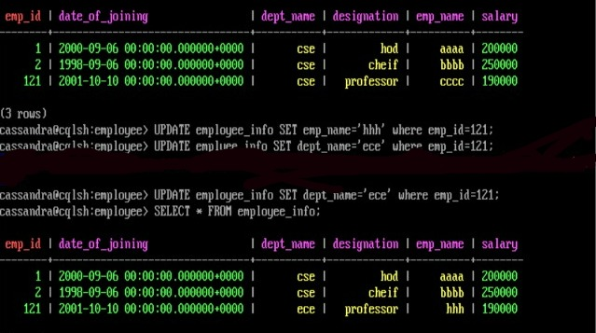

**5:**

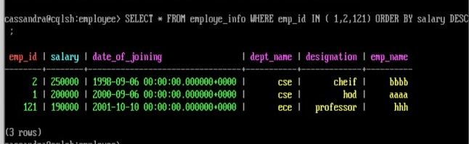

**6:**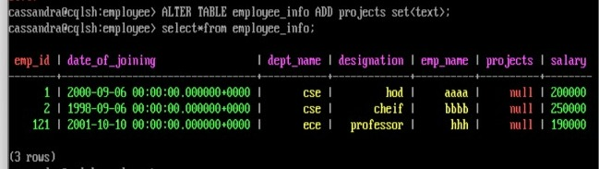

**7:**

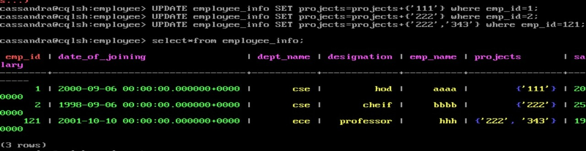

**8.**

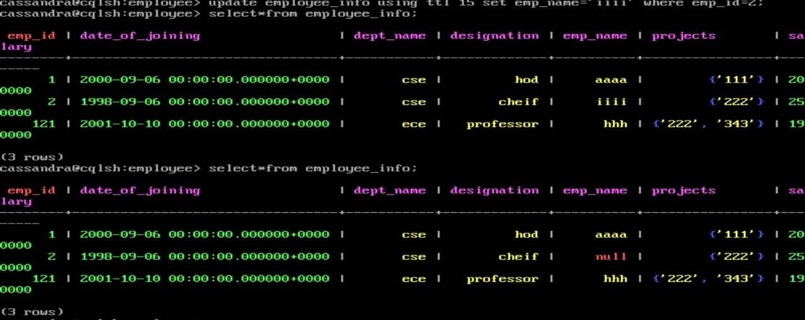

## EXPERIMENT 3

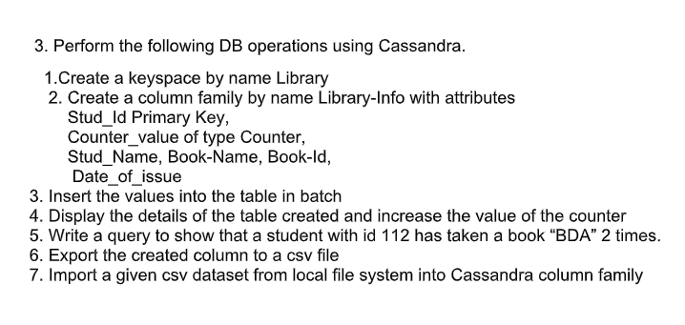

|  |
| --- |
| 1 Create a key space by name Library |
|  |  |
|  | CREATE KEYSPACE lib WITH replication={'class':'SimpleStrategy','replication_factor' : 3}; |
|  | o/p: |
|  | describe keyspaces; |
|  |  |
|  | library1 system_auth system system_distributed employee1 |
|  | lib bhuvana students employee employeelab1 |
|  | "Students" newstudents employee_db system_traces |
|  | system_schema lab employee_224 students1 |
|  |  |
|  | 2. Create a column family by name Library-Info with attributes Stud_Id Primary Key,Counter_value of type Counter,Stud_Name, Book-Name, Book-Id, Date_of_issue. |
|  |  |
|  | CREATE TABLE library_info(stud_id int,counter_value counter,stud_name text,book_name text,book_id int,date_of_issue timestamp,PRIMARY KEY(stud_id,stud_name,book_name,book_id,date_of_issue)); |
|  |  |
|  | o/p: SELECT * FROM lib.library_info; |
|  |  |
|  | stud_id | stud_name | book_name | date_of_issue | book_id | counter_value |
|  | ---------+-----------+-----------+---------------+---------+--------------- |
|  | ---------------------------------------------------------------------------------------------------- |
|  |  |
|  | 3. Insert the values into the table in batch |
|  |  |
|  | UPDATE library_info SET counter_value = counter_value+1 WHERE stud_id=111 and stud_name='sam' and book_name='ml' and date_of_issue='2020-10-12' and book_id=201; |
|  | UPDATE library_info SET counter_value = counter_value+1 WHERE stud_id=112 and stud_name='ram' and book_name='bda' and date_of_issue='2020-10-22' and book_id=205; |
|  | UPDATE library_info SET counter_value = counter_value+1 WHERE stud_id=113 and stud_name='siri' and book_name='ml' and date_of_issue='2020-10-20' and book_id=206; |
|  |  |
|  | o/p:SELECT * FROM lib.library_info; |
|  |  |
|  | stud_id | stud_name | book_name | date_of_issue | book_id | counter_value |
|  | ---------+-----------+-----------+---------------------------------+---------+--------------- |
|  | 111 | sam | ml | 2020-10-11 18:30:00.000000+0000 | 201 | 1 |
|  | 113 | siri | ml | 2020-10-19 18:30:00.000000+0000 | 206 | 1 |
|  | 112 | ram | bda | 2020-10-21 18:30:00.000000+0000 | 205 | 1 |
|  |  |
|  | ------------------------------------------------------------------------------------------------------ |
|  |  |
|  |  |
|  | 4. Display the details of the table created and increase the value of the counter |
|  |  |
|  | UPDATE library_info SET counter_value = counter_value+1 WHERE stud_id=113 and stud_name='siri' and book_name='ml' and date_of_issue='2020-10-20' and book_id=206; |
|  |  |
|  | SELECT * FROM lib.library_info; |
|  |  |
|  | stud_id | stud_name | book_name | date_of_issue | book_id | counter_value |
|  | ---------+-----------+-----------+---------------------------------+---------+--------------- |
|  | 111 | sam | ml | 2020-10-11 18:30:00.000000+0000 | 201 | 1 |
|  | 113 | siri | ml | 2020-10-19 18:30:00.000000+0000 | 206 | 2 |
|  | 112 | ram | bda | 2020-10-21 18:30:00.000000+0000 | 205 | 1 |
|  |  |
|  |  |
|  | --------------------------------------------------------------------------------------------------- |
|  |  |
|  |  |
|  | 5. Write a query to show that a student with id 112 has taken a book “BDA” 2 times. |
|  |  |
|  | SELECT *FROM library_info WHERE stud_id=112; |
|  |  |
|  | o/p: stud_id | stud_name | book_name | date_of_issue | book_id | counter_value |
|  | ---------+-----------+-----------+---------------------------------+---------+--------------- |
|  | 112 | ram | bda | 2020-10-21 18:30:00.000000+0000 | 205 | 2 |
|  |  |
|  | 6. Export the created column to a csv file |
|  | COPY library_info(stud_id,counter_value,stud_name,book_name,book_id,date_of_issue) TO 'e:\libraryinfo.csv'; |
|  |  |
|  | o/p: |
|  | Using 11 child processes |
|  |  |
|  | Starting copy of lib.library_info with columns [stud_id, counter_value, stud_name, book_name, book_id, date_of_issue]. |
|  | Processed: 3 rows; Rate: 24 rows/s; Avg. rate: 24 rows/s |
|  | 3 rows exported to 1 files in 0.136 seconds. |
|  |  |
|  |  |
|  | 7. Import a given csv dataset from local file system into Cassandra column family |
|  |  |
|  | CREATE TABLE library_info1(stud_id int,counter_value counter,stud_name text,book_name text,book_id int,date_of_issue timestamp,PRIMARY KEY(stud_id,stud_name,book_name,book_id,date_of_issue)); |
|  |  |
|  | SELECT * FROM library_info1; |
|  |  |
|  | stud_id | stud_name | book_name | book_id | date_of_issue | counter_value |
|  | ---------+-----------+-----------+---------+---------------+--------------- |
|  |  |
|  |  |
|  | COPY library_info1(stud_id,counter_value,stud_name,book_name,book_id,date_of_issue) TO 'e:\libraryinfo.csv'; |
|  |  |
|  |  |
|  |  |
|  | o/p:Using 11 child processes |
|  |  |
|  | Starting copy of lib.library_info1 with columns [stud_id, counter_value, stud_name, book_name, book_id, date_of_issue]. |
|  | Processed: 3 rows; Rate: 5 rows/s; Avg. rate: 7 rows/s |
|  | 3 rows exported to 1 files in 0.135 seconds. |

**1,2:**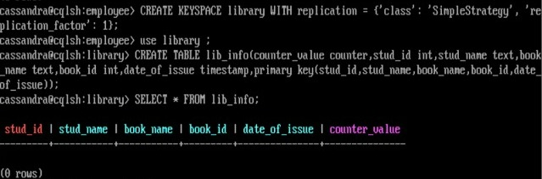

**3:**

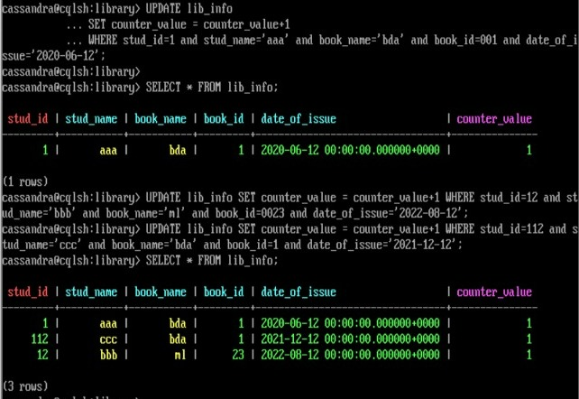

**4.**

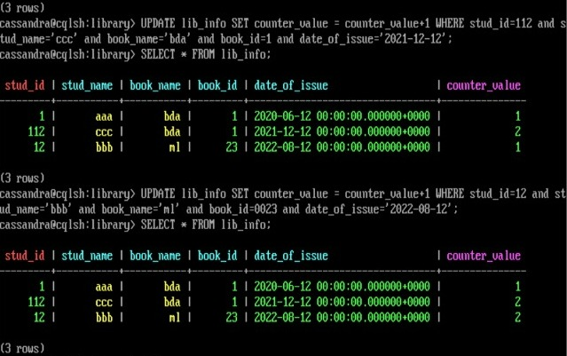

**5.**

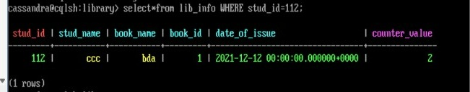

**6.**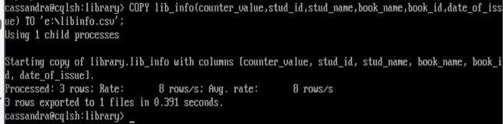

**7.**

